END USER DOCUMENTATION
Version 1

A Project On

SEISMIC ACQUISITION 3D MAPPING SYSTEM

GROUP – 2 (METAMINDS)
NANDEESWAR BADUGU
SAI KISHORE BHADRAGIRI
SAITEJA SIRIPURAPU
JAYTHRI PUPPALA

Table of Contents

- INTRODUCTION 2
- SYSTEM REQUIREMENTS 2
- SYSTEM CONFIGURATION GUIDE 2
- INPUT PARAMETERS 3
- OUTPUT PARAMETERS 3
- GLOSSARY 4

- INTRODUCTION

This application is designed for seismic acquisition analysis, and provides a comprehensive visualization of geophones, sources, and bins (midpoints). It also calculates offsets (distances between geophones and sources) and multiplicity (the number of overlaps at each midpoint). The application allows users to validate spatial layouts, analyze offset distributions, and understand data multiplicity for seismic surveys.

- System Requirements
- Hardware:
- Processor: i5 or higher
- RAM: 8 GB or more
- Hard Disk: 30 GB or more free space
- Software:
- Python 3.7 or later
- Required libraries: numpy, matplotlib, shapely, tkinter, python-docx
- Operating System: Windows, macOS, or Linux

- System Configuration Guide
3.1 Installation
- Install Python 3.7 or later.
- Install required libraries using:
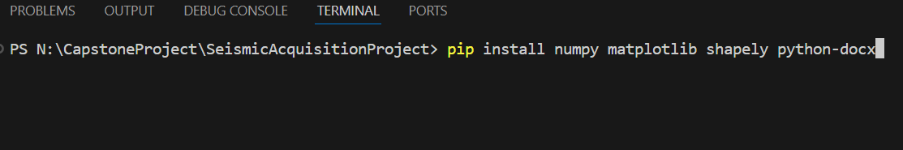
3.2 Launch the Application
- Run the script: python seismic_acquisition.py
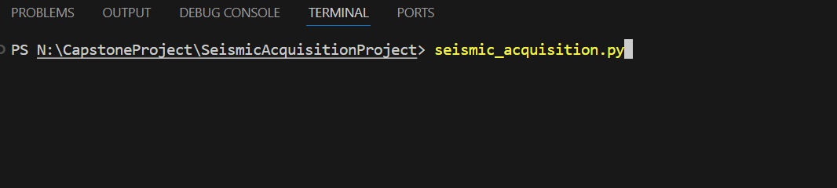

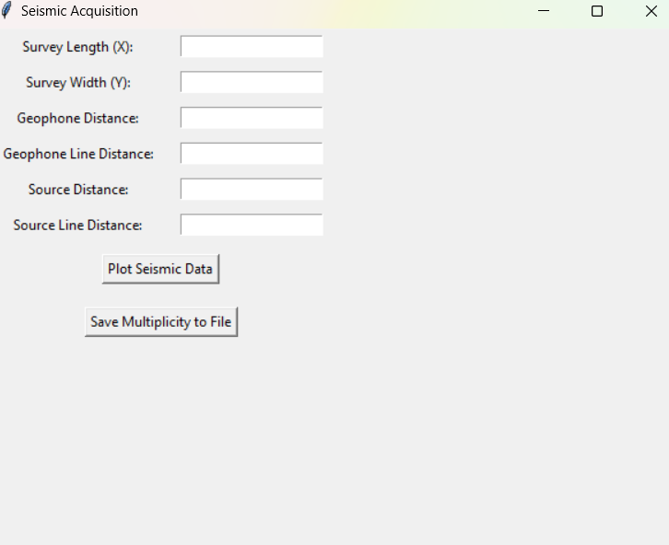
3.3 Application Interface

- Seismic Acquisition GUI with input fields for survey parameters.
- Input fields for:
- Survey Length (X): Horizontal extent of the survey area.
- Survey Width (Y): Vertical extent of the survey area.
- Geophone Distance: Distance between adjacent geophones.
- Geophone Line Distance: Distance between rows of geophones.
- Source Distance: Distance between adjacent sources.
- Source Line Distance: Distance between rows of sources.
- Buttons for:
- Plot Seismic Data: Generates visualizations of geophones, sources, and bins.
- Save Multiplicity to File: Exports multiplicity data to a .docx file.

- How to Use
Input Parameters
- Enter values for the survey area, geophone distances, and source distances.
- Survey Length (X): Survey area extent in the x-direction (meters/miles).
- Survey Width (Y): Survey area extent in the y-direction (meters/miles).
- Geophone Distance: Distance between geophones in a line (meters/miles).
- Source Distance: Distance between source points in a line (meters/miles).
- Source Line Distance: Distance between sources lines (meters/miles).
- Ensure all inputs are positive numeric values and non-zero values.
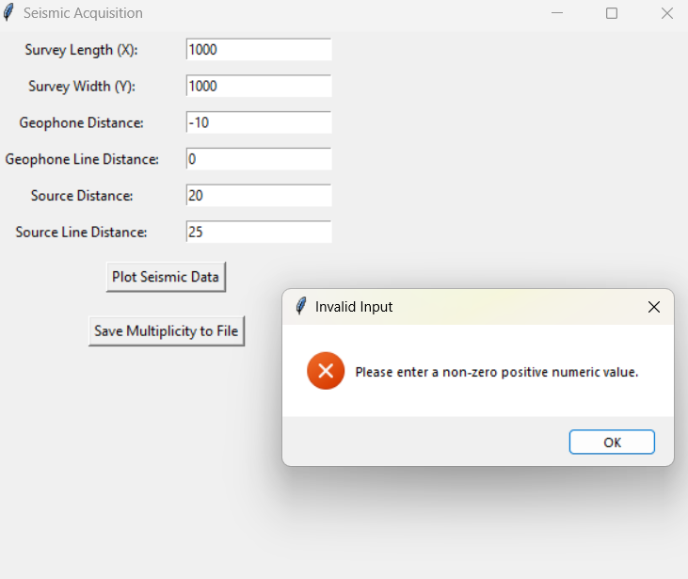

Error message displayed for invalid input parameters (negative or zero values). The application prompts the user to enter non-zero positive numeric values.
- Output Parameters

  - Geophone, Source, and Multiplicity Visualized on a 2D scatter plot.
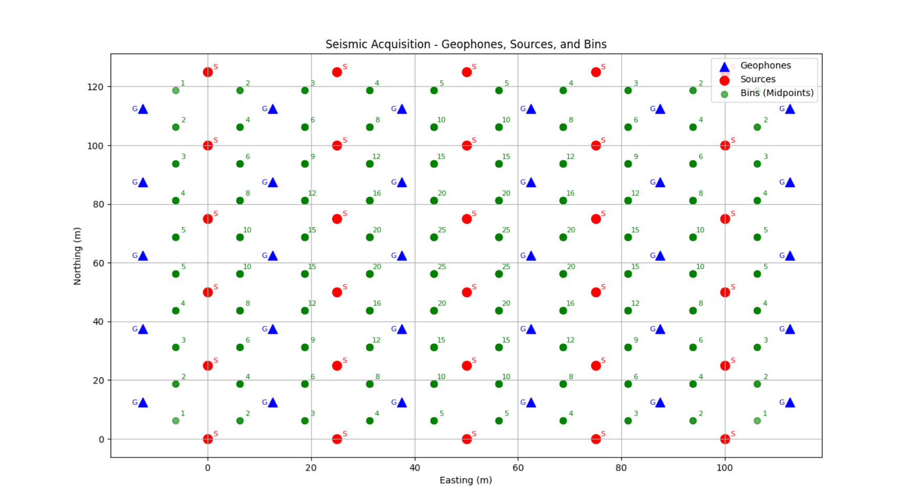
Geophones (blue triangles), sources (red circles), and bins (green points) plotted based on user input.
- Geophones: Represented as blue triangles on the grid.
- Sources: Represented as red circles.
- Bins (Midpoints): Represented as green dots, calculated as the center between each geophone-source pair.
- Annotations:
  - Coordinates of geophones and sources displayed near their respective points.
  - Multiplicity values displayed at each midpoint.

  - Offset Distribution
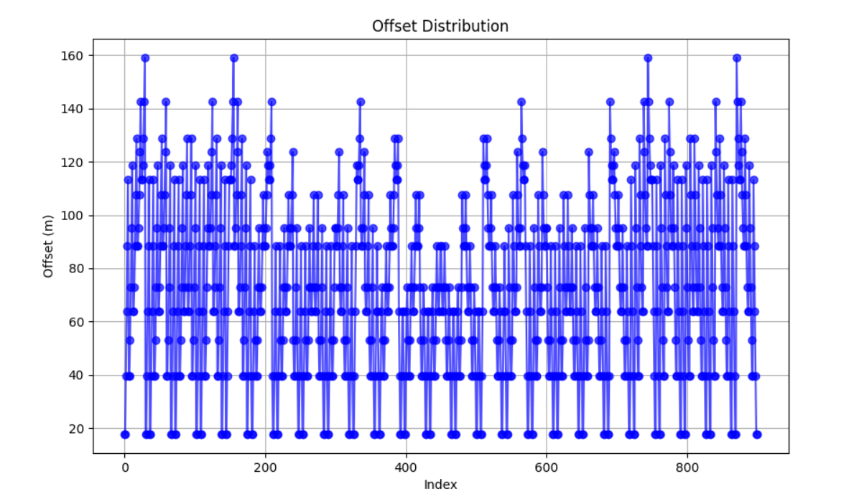
Histogram showing the frequency of offsets between geophones and sources.
Caption: Offset distribution graph showing calculated distances between geophones and sources.
- X-axis: Offset values in meters.
- Y-axis: Frequency of occurrence.
5.3 Exporting Data
- Click Save Multiplicity to File to:
- Save multiplicity values in a Word document (multiplicity_values.docx) located in the Downloads folder.
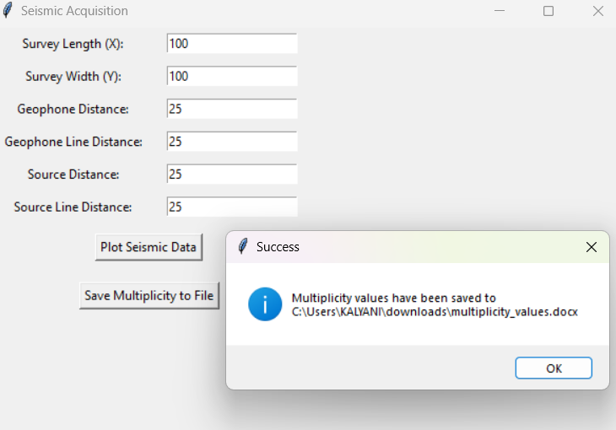

Success message confirming that multiplicity values have been saved to the specified file location.
- Glossary
- Geophone: A device that detects ground motion and converts it into electrical signals.
- Source Distance: Horizontal spacing between seismic sources.
- Multiplicity: Number of unique source-receiver pairs sampling a subsurface point.
- Offset: Distance between source and receiver.

